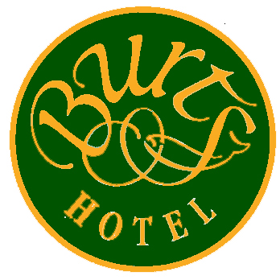

Christmas Day Lunch 2013

Roast Butternut Squash Soup with Crème Fraiche Profiteroles
Confit Duck and Foie Gras Roulade, Spiced Pear and Cranberry Compote
Eyemouth Crab, Three Ways: Tian, Crab Cake, Spring Roll, Dill and Lime Crème Fraiche
Twice Baked Cheese Soufflé, Grape and Apple Salad, Port Reduction (V)

***

Crayfish and Smoked Salmon Cocktail

***

Ballontine of Turkey, Sage, Onion and Chestnut Stuffing, Caramelised Root Vegetables, Bacon Chipolatas, Turkey Jus
Grilled Lemon Sole Fillets, Crab Confit Potatoes, Crayfish Sauce, Cauliflower and Bean Salad
Roast Loin of Lamb, Wrapped with Herb Mousse, Dauphinoise Potatoes, Fricassee of Vegetables, Rosemary Jus
Medallion of Beef Fillet with Mushroom Gratin, Turnip Potato Cake, Spinach, Caramelised Carrots, Garlic Jus
Open Wild Mushroom, Spinach and Artichoke Lasagne, Truffle Foam, Parmesan (V)

***

Traditional Christmas Pudding, Clementine Ice Cream, Brandy Sauce
Apple Crumble, Apple Sponge, Apple Ice Cream, Cinnamon Anglaise
Chocolate and Amaretto Cake, Coffee Crème Brulee, Amaretto Ice Cream
Selection of Scottish and Border Cheeses with Walnut and Raisin Bread and Apple Chutney

***

Coffee and Home-made Mince Pies

£68.00 per person inclusive of VAT

Please note that we cannot guarantee that any product on this menu is totally free from nuts or nut derivatives

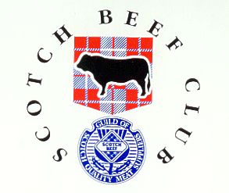

£47.75per person

May we ask you to refrain from Smoking in our Restaurant. Thank you.

Please note that we cannot guarantee that any product on this menu is totally free from nuts or nut derivatives

